Logo
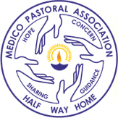

St Mark’s Cathedral, Bangalore
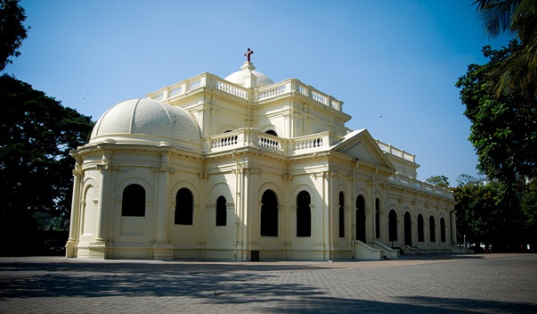

Dr. Joyce Siromani
Founder and First Secretary of MPA
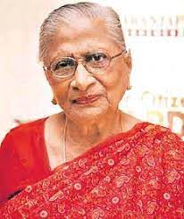

Foundation stone laying by G V K Rao (Chief Secretary)
(in the presence of Benjamin Isaac, R M Varma, S S Jayaram, besides others)
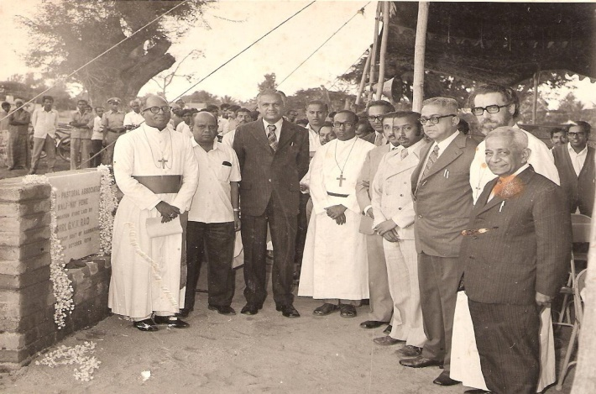
First building completed, the Administrative Block
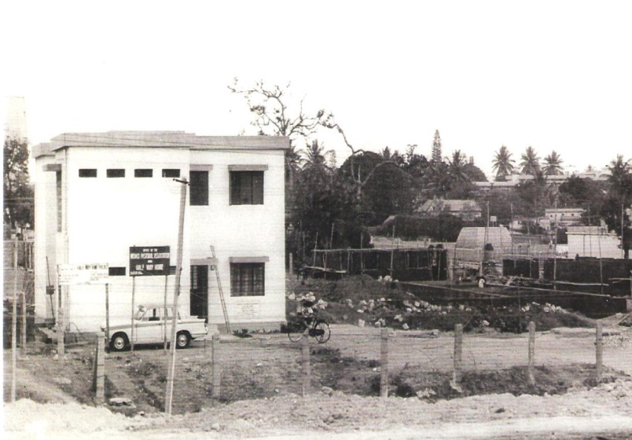
The Half Way Home
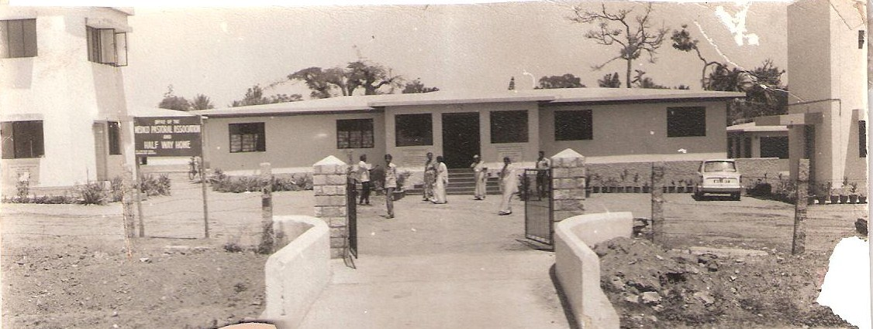

Half- Way Home (present)
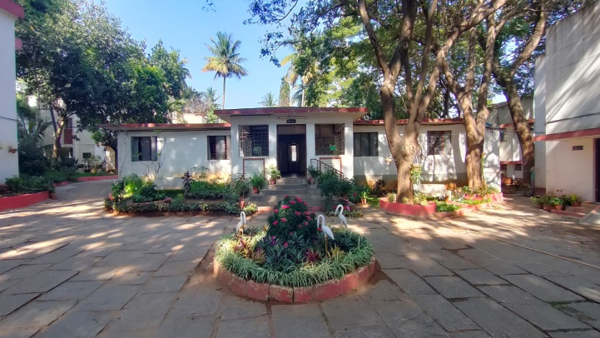
Navajeevan Hostel
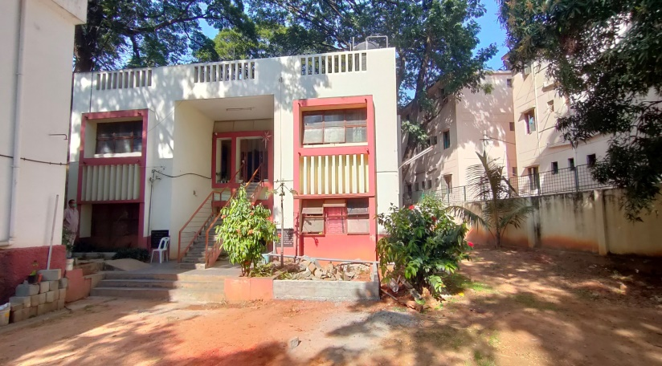
Ladies Cottage
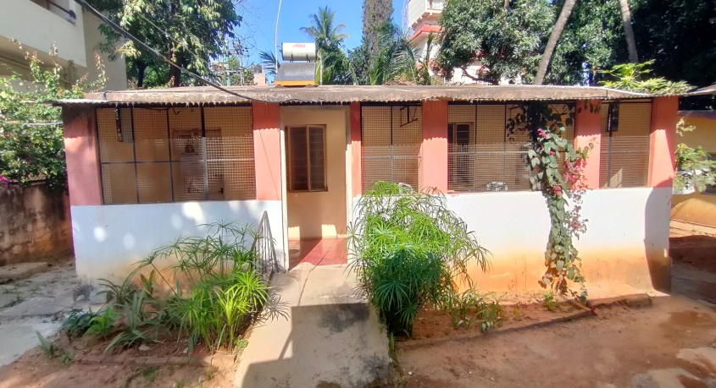

Auditorium
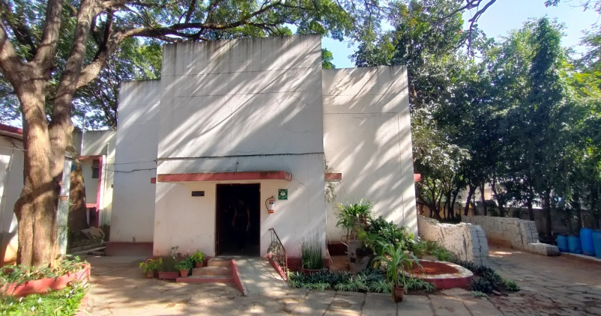
Staff Quarters
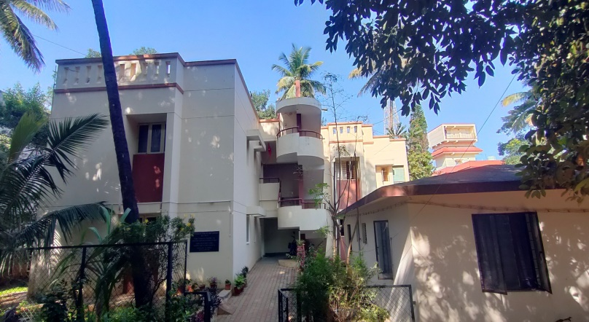

Staff Photos
Administrative

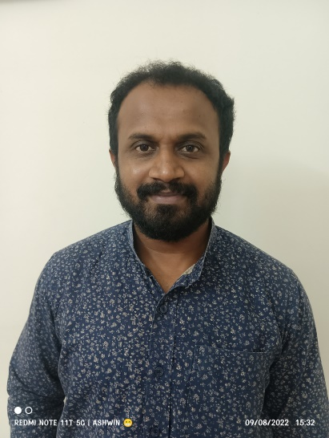
Bhaskar N G
Administrator

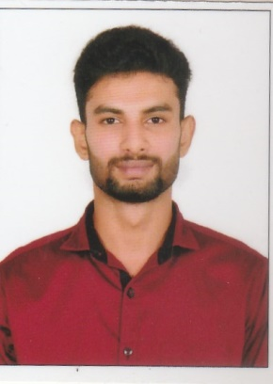
Sajan K.S
Accountant

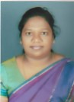
Anita Charles
Receptionist

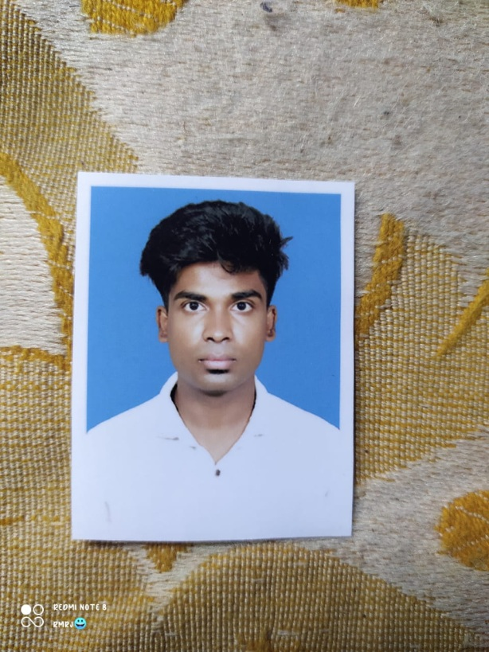
Rakesh R
Office Assistant

Clinical Staff

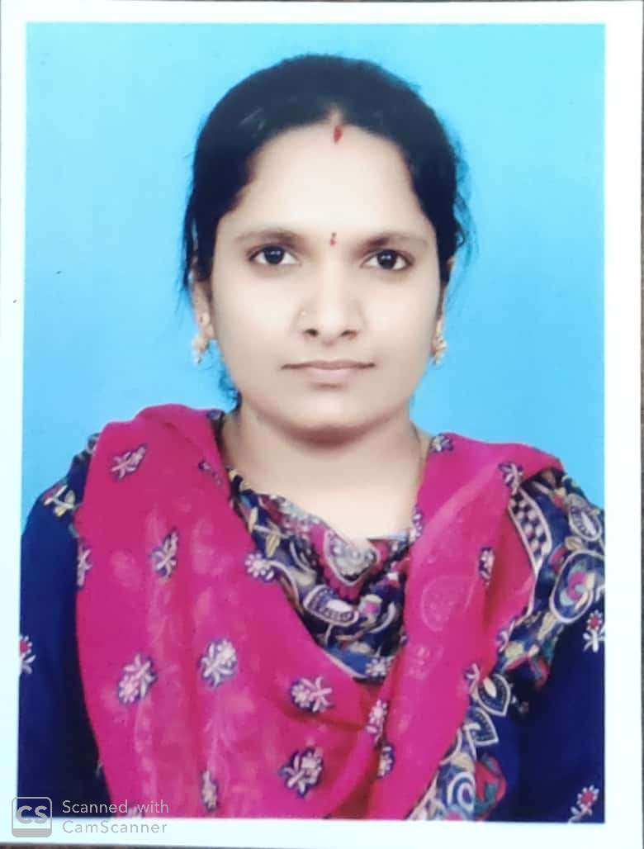
Agalya. V
Joint senior Counsellor

Aneesh Thomas
Joint senior Counsellor

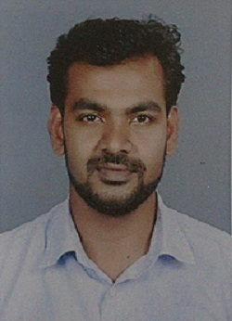

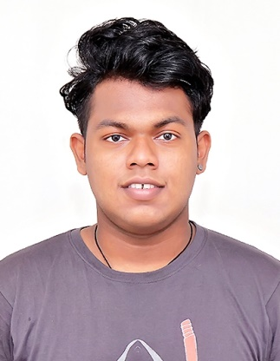
Ashwin O B
Counsellor

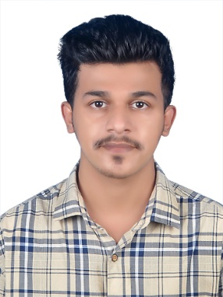
Syed Zaeem Jifri Counsellor

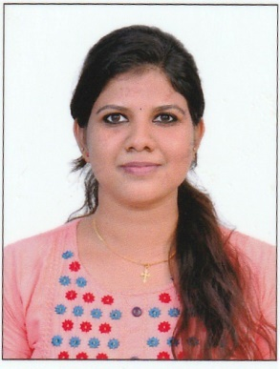
Reshma J
Counsellor

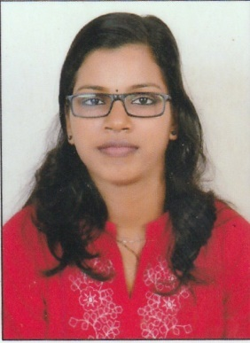
Amrutha B
Counsellor

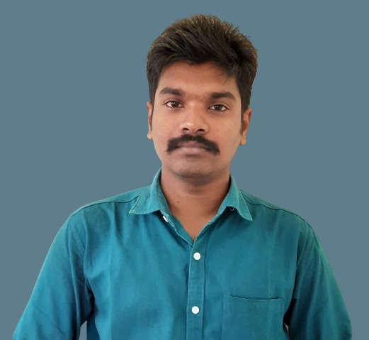
Denil Varghese
Residential Counsellor

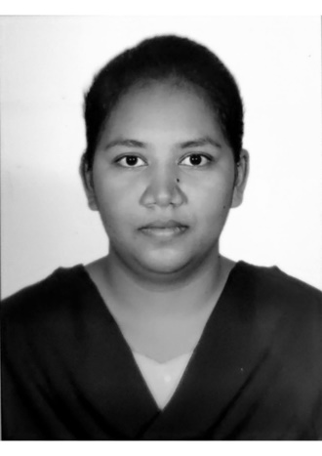
P. Mercy Jyothsna
Residential Nurse

Facility Staff
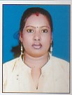
Mary Stella
Ass .Rehab Facility Manager

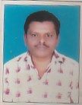
Ravi C Mark
Cook

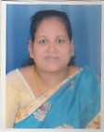
Ganga S
Cook

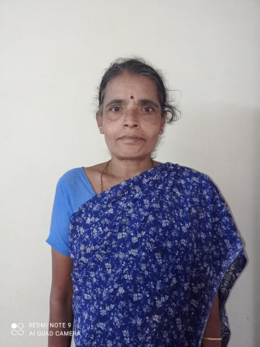
Geetha R
Helper

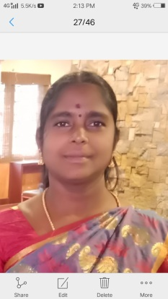
Muniyamma
Helper

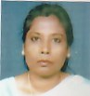
Amudha
Helper

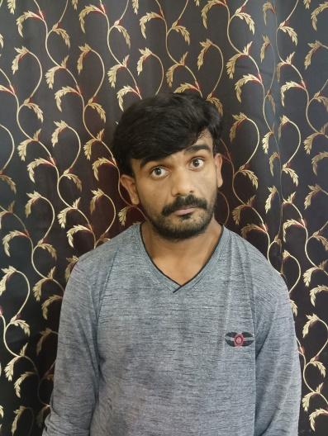
Chethan J N
Gardner

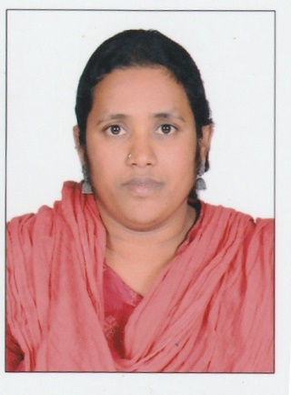
Maria B

Helper

Roja Lilly Mary

Helper

Awards
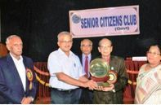
In 2012, MPA received the Padmabushan Doctor M.C. Modi Service Award for the second time from the Senior Citizens Club (Government), Bangalore.
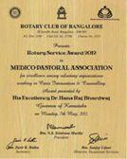
In 2012, MPA received Rotary Service Award for Excellence among NGO’s (Voluntary Organizations) Working in Counselling and Crisis Intervention

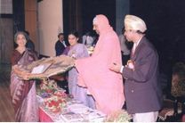

In 2000, MPA received the Distinguished Service Award from the Indian Psychiatric Society, Karnataka Branch.
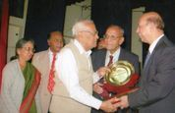
In 2007, MPA received the Padmabushan Doctor M.C. Modi Service Award from the Senior Citizens Club (Government), Bangalore.

PROGRAM
LECTURE SERIES
THE LECTURE SERIES IS BASED ON THE 5O^{th} YEAR OF SERVICE OF MENTAL YEAR FULL OF LECTURE
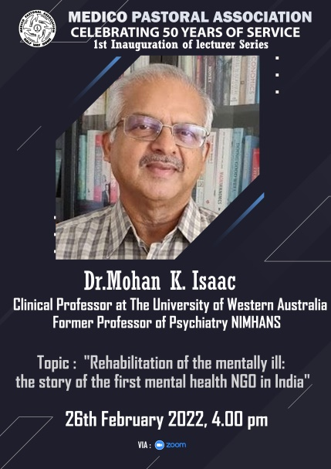
Lecture 1:
Dr. Mohan Isaac he inaugurates the series with is lecture the topic of the lecture is “rehabilitation of mental ill: the story of the first mental health NGO in India”.

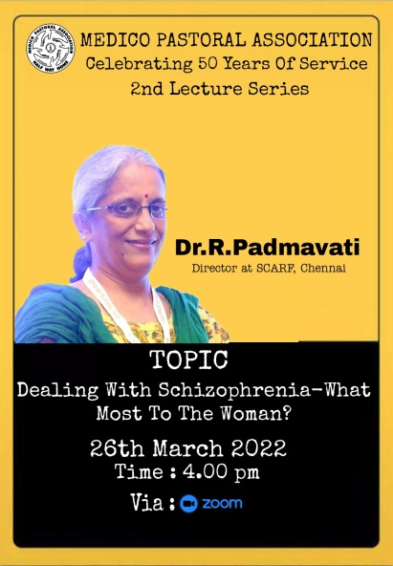
Lecture 2:
Dr.R.Padmavati is a lecturer for the second series the topic is Dealing with Schizophrenia –What most to the Woman?
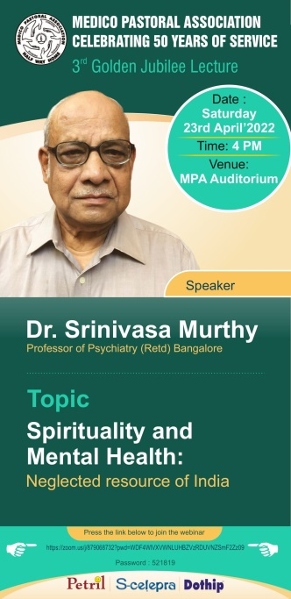
Lecture 3:
Dr.Srinivasa Murthy is a lecturer for the 3rd series the topic is Spirituality and Mental Health: Neglected resource of India.

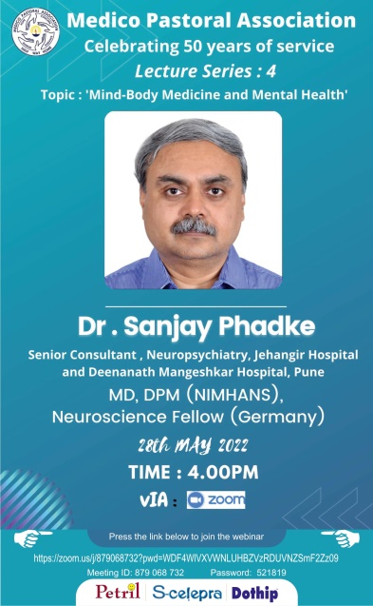
Lecture 4:
Dr.Sanjay Phadke is a lecturer for the 4th series the topic is “Mind-Body Medicine and Mental Health”

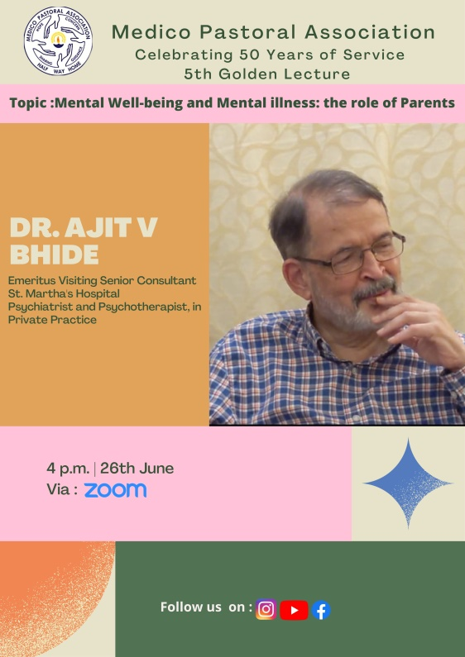
Lecture 5:
Dr.Ajith V Bhide is a lecturer for the 5th series the topic is Mental Well-being and Mental illness: the role of parents
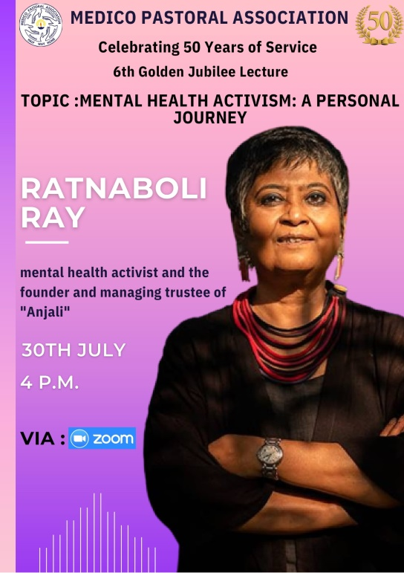
Lecture 6:
Ratnaboli Ray is a lecturer for the 6th series the topic is Mental Health Activism: A Personal Journey

Christmas Celebration
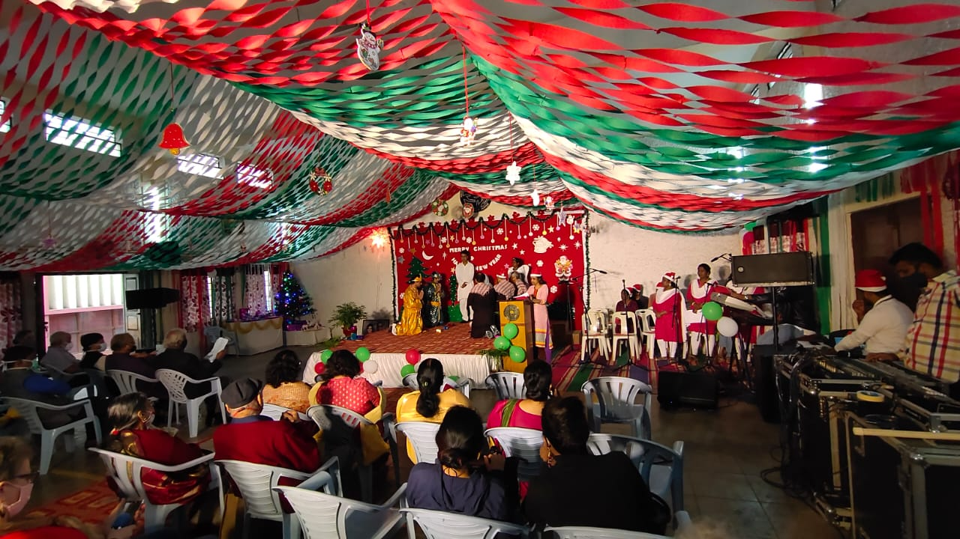

Observing WMHD- Inter Psycho-Social Rehabilitation Competition
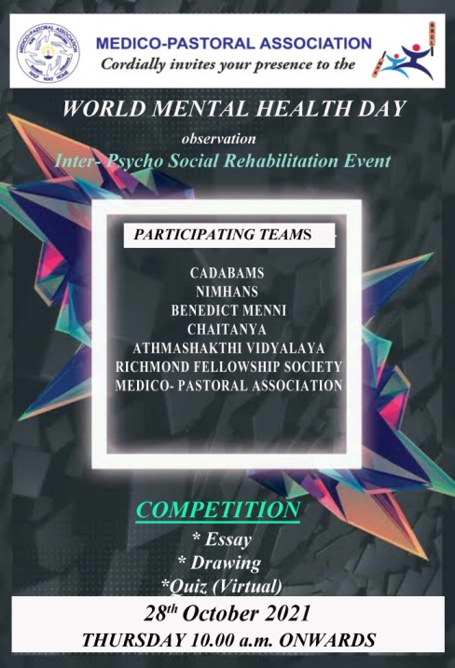
On the occasion of observing World Mental Health Day, MPA has a history of conducting BRCL (Bangalore Rehabilitation Cricket League) tournament with other psycho-social rehabilitation but past two years, due to COVID-19 Pandemic the tournament has been postponed indefinitely. To continue the spirit of enthusiasm and motivation of the residents of various organizations this year we organized (virtual event) with few competitions for the residents of different Psycho- Social Rehabilitation centers.
On Thursday, 28th October, 2021 Inter –Psycho Social Rehabilitation Competition was organized by the Medico-Pastoral Association among Cadabams, NIMHANS, Athma Shakthi Vidyalaya, Richmond Fellowship Society, Benedict Menni Rehab Centre Trivandrum Kerala and Chaitanya Institute of Mental Health Pune.

Women’s Day Celebration
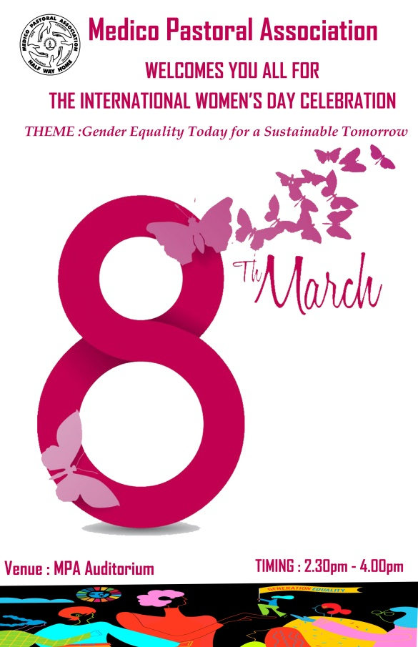

Foundation day 2022
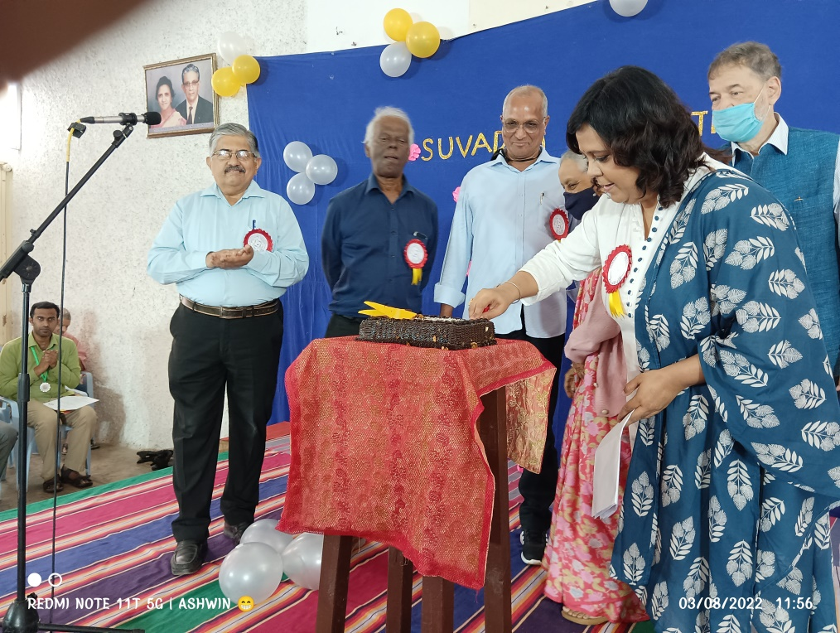

The Foundation Day of MPA was observed on 3 rd August 2022 as part of Golden JubileeYear celebration. The day was celebrated by acknowledging and thanking the people whohelp MPA for its daily functioning.
Dr.Joyce Siromoni Birthday

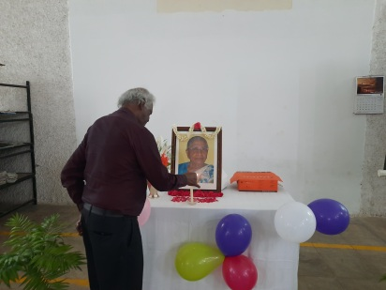
On 22nd October 2021, we remembered and celebrated the birthday of Dr. Joyce Siromoni founder and the first Secretary of Medico Pastoral Association in MPA auditorium. The programme started with a prayer song. Gathering was welcomed &amp; introduction was given by Mr. Samuel Mohan, Secretary. Cake cutting by our senior resident Ms. Yangke Laden followed. Wishes shared by all the members and staff. Few games were conducted for the residents, and the programme ended with a song by residents.

